**Problem Statement :** Solve the given postfix expression “23*45+*” using Stack in Python

**Objective :** To Solve the given postfix expression “23*45+*” using Stack in Python

**Source Code :**

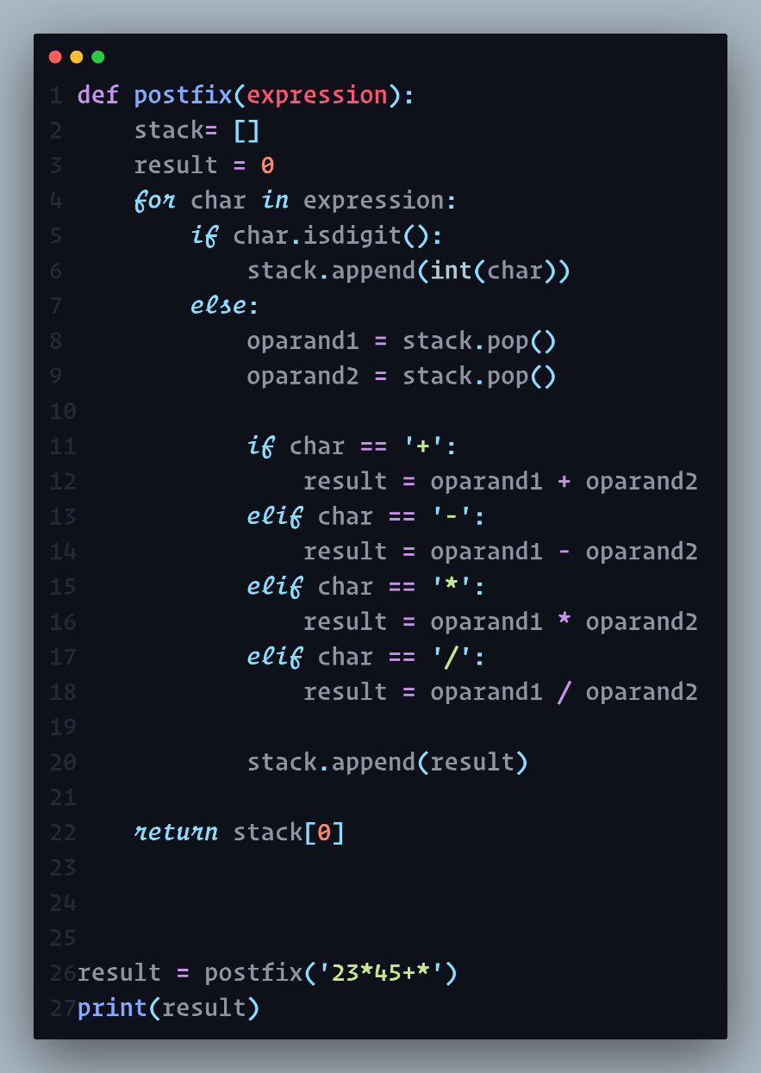

**Output :**

